Wastewater Dashboard Access Instructions
(Tableau Public)
Contents
Quick Guide 1
Navigating SARS-CoV-2 Screen 4
Navigating Influenza A Screen 8
Navigating Influenza B Screen 10
Navigating RSV Screen 13
Filtering and Highlighting Data 16
Downloading Data 19
Using this Data and Limitations 20

Quick Guide
- Select pathogen of interest from options bar (top center)
  - The line chart shows the average concentration of the selected pathogen normalized to fecal matter (center left).
  - Summary trends are displayed in the trend by service area map and trend by service area table (center right).
  - SARS-CoV-2 only: The most predominant lineage detected by sequencing is displayed by service area (center right).
  - Details on the normalization method and trend calculations can be found under the “Definitions” section (bottom).
Note: By default, data from all service areas will be displayed.
- Filter data by service area
  - Select a service area under “Service Area Filer” (top left).
  - Data from only the selected service area will be displayed on the line chart and table.
- Highlight data by service area
  - Select a service area under “Service Area Key (Color)” or “Service Area Key (Shape)” (top left).
    - Note: Data can also be highlighted by clicking within the line chart, map, or tables.
  - Data from only the selected service area will be highlighted in the line chart, map, and tables. Data from other service areas will be grayed out, but still visible.
- Download data
  - Data from the dashboards can downloaded by clicking (lower right)
  - Multiple file formats are supported including png, pdf, xlsx, csv, pptx, and twbx.
Accessing and Navigating Wastewater Dashboard
- In any web browser enter the following URL into the address bar: https://public.tableau.com/app/profile/shl.uiowa/viz/SHLWastewaterWWTPDashboard/WastewaterTestingbyServiceArea
- Once the dashboard loads your screen should resemble Screenshot 1.

Screenshot 1
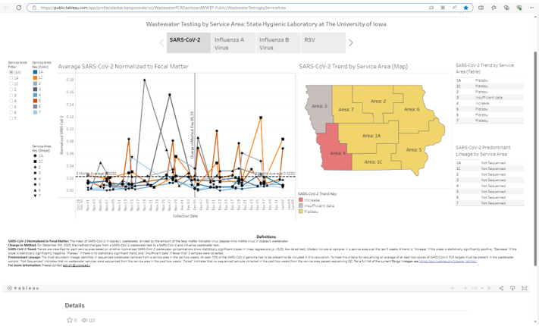
- By default, data related to SARS-CoV-2 will be shown.
- SARS-CoV-2, Influenza A Virus, Influenza B Virus, or RSV (Respiratory Syncytial Virus) data can be selected by clicking on the options at the top of the dashboard (Screenshot 2).
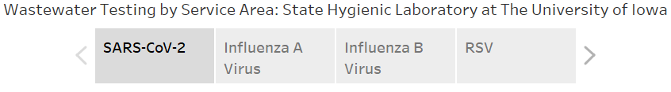
Screenshot 2
- To view the data in full screen mode, select the symbol in the lower right corner. To exit full screen mode, click the esc key on your keyboard or select the symbol in the lower right corner.

Navigating SARS-CoV-2 Screen
- Starting on the lefthand side of the screen there are filter, color, and shape keys corresponding to the Average SARS-CoV-2 Normalized to Fecal Matter line chart (Screenshot 3).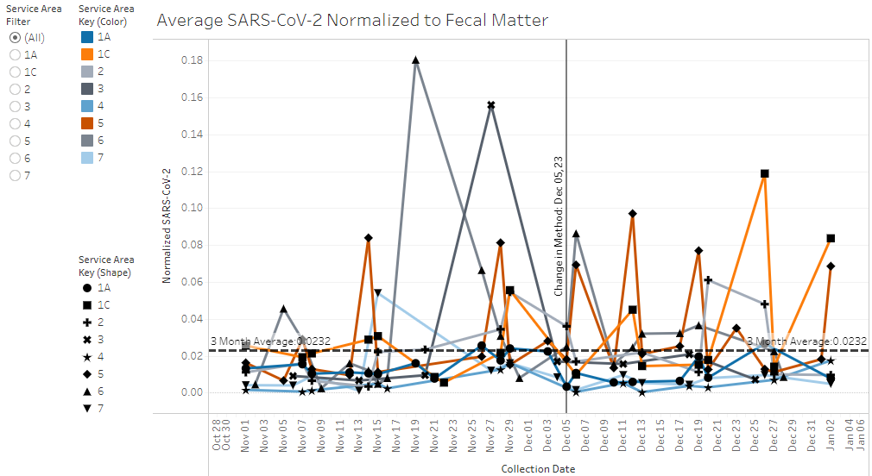
Screenshot 3

- The filter for Iowa Health and Human Services service areas shows the data for the selected option on the Average SARS-CoV-2 Normalized to Fecal Matter line chart and SARS-CoV-2 Trend by Service Area table. Options include "All" and each service area.
- The color key for Iowa Health and Human Services service areas shows the colors used to highlight specific service areas on the Average SARS-CoV-2 Normalized to Fecal Matter line chart.
- The shape key for Iowa Health and Human Services service areas shows the shapes used to highlight specific service areas on the Average SARS-CoV-2 Normalized to Fecal Matter line chart.
- The line chart shows average SARS-CoV-2 normalized to fecal matter. For each of the eight service areas as defined by Iowa Health and Human Services, the trend of the normalized SARS-CoV-2 is shown over the last 3 months. Trends and data points from each of the eight service areas are distinguished based on color and shape respectively. On December 5th, 2023, the method changed from a SARS-CoV-2 digital droplet wastewater test to a SARS-CoV-2 and influenza digital wastewater test.
- To the right of the line chart is the SARS-CoV-2 Trend by Service Area (Map) and trend key (Screenshot 4).
Screenshot 4
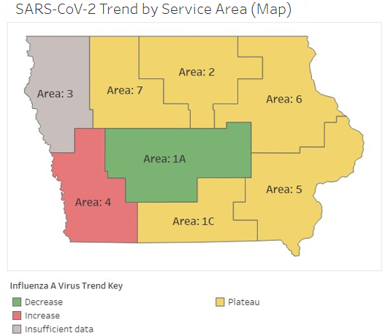
- The Map shows the state of Iowa divided into eight service areas defined by Iowa Health and Human Services. The service areas are categorized as increase, decrease, plateau, and insufficient data based on the SARS-CoV-2 trend calculations. See the Definitions section at the bottom of the dashboard for more details.
- The trend key for the four categories shows different colors for the different trends.
- To the right of the map are the SARS-CoV-2 Trend by Service Area (Table) tables and the SARS-CoV-2 Predominant Lineage by Service Area tables (Screenshot 5).

Screenshot 5

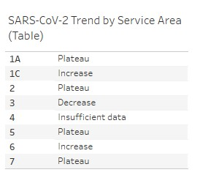
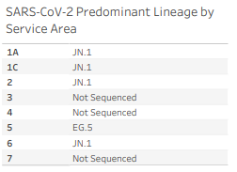

- SARS-CoV-2 Trend by Service Area (Table) provides an alternative representation of the SARS-CoV-2 Trend by Service Area map. The table displays rows for the eight service areas as defined by Iowa Health and Human Services. The service areas are categorized as increase, decrease, plateau, and insufficient data based on the SARS-CoV-2 trend calculations.
- SARS-CoV-2 Predominant Lineage by Service Area displays rows for the eight service areas as defined by Iowa Health and Human Services. Each row displays the most predominant lineage, “Failed”, or “Not Sequenced” as determined by an internal calculation.
- Further details on the methods can be found at the bottom of the screen in the Definitions section.

Navigating Influenza A Screen
- Starting on the lefthand side of the screen there are filter, color, and shape keys corresponding to the Average Influenza A Normalized to Fecal Matter line chart (Screenshot 6).
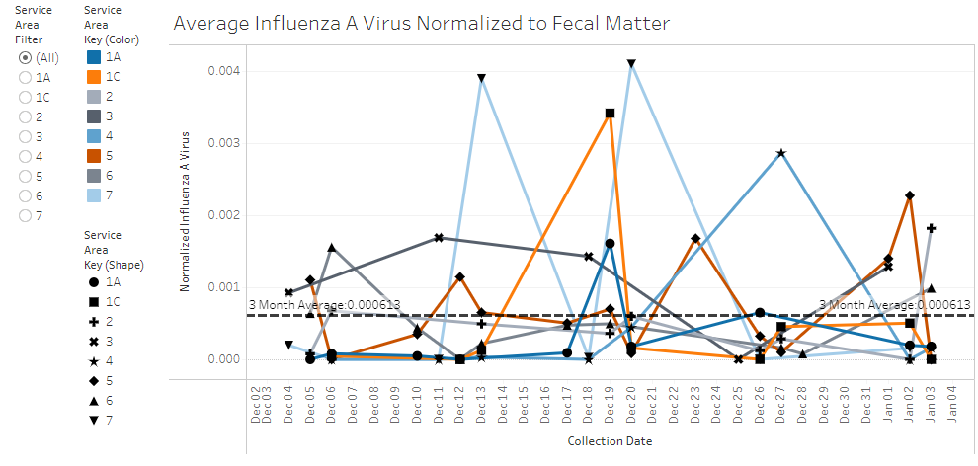
Screenshot 6
- The filter for Iowa Health and Human Services service areas shows the data for the selected option on the Average Influenza A Virus Normalized to Fecal Matter line chart and Influenza A Virus Trend by Service Area table. Options include "All" and each service area.
- The color key for Iowa Health and Human Services service areas shows the colors used to highlight specific service areas on the Average Influenza A Virus Normalized to Fecal Matter line chart.
- The shape key for Iowa Health and Human Services service areas shows the shapes used to highlight specific service areas on the Average Influenza A Virus Normalized to Fecal Matter line chart.
- The line chart shows average influenza A virus normalized to fecal matter. For each of the eight service areas as defined by Iowa Health and Human Services, the trend of the normalized influenza A virus is shown over the last three months. Trends and data points from each of the eight service areas are distinguished based on color and shape respectively.
- To the right of the line chart is the Influenza A Trend by Service Area (Map) and trend key (Screenshot 7).
Screenshot 7

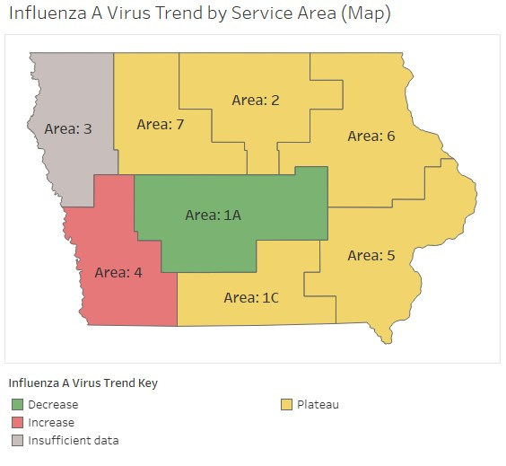
- The map shows the state of Iowa divided into eight service areas defined by Iowa Health and Human Services. The service areas are categorized as increase, decrease, plateau, and insufficient data based on the influenza A virus trend calculations. See the Definitions section at the bottom of the dashboard for more details.
- The trend key for the four categories shows different colors for the different trends.
- To the right of the map is the Influenza A Virus Trend by Service Area (Table) (Screenshot 8).

Screenshot 8
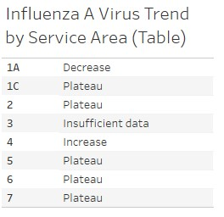
- The table provides an alternative representation of the Influenza A Virus Trend by Service Area map. The table displays rows for the eight service areas as defined by Iowa Health and Human Services. The service areas are categorized as increase, decrease, plateau, and insufficient data based on the influenza A virus trend calculations.
- Further details on the methods can be found at the bottom of the screen in the Definitions section.

Navigating Influenza B Screen
- Starting on the lefthand side of the screen there are filter, color, and shape keys corresponding to the Average Influenza B Normalized to Fecal Matter line chart (Screenshot 9).
Screenshot 9
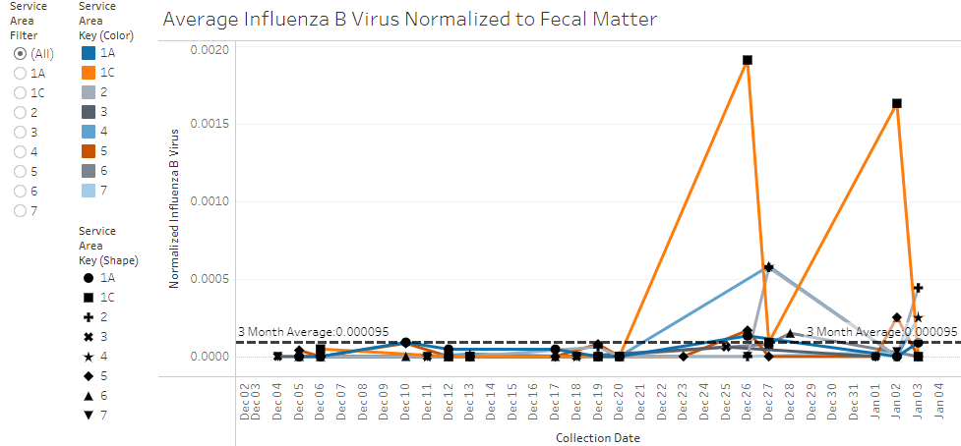
- The filter for Iowa Health and Human Services service areas shows the data for the selected option on the Average Influenza B Virus Normalized to Fecal Matter line chart and Influenza B Virus Trend by Service Area table. Options include "All" and each service area.
- The color key for Iowa Health and Human Services service areas shows the colors used to highlight specific service areas on the Average Influenza B Virus Normalized to Fecal Matter line chart.
- The shape key for Iowa Health and Human Services service areas shows the shapes used to highlight specific service areas on the Average Influenza B Virus Normalized to Fecal Matter line chart.
- The line chart shows average influenza B virus normalized to fecal matter. For each of the 8 service areas as defined by Iowa Health and Human Services, the trend of the normalized influenza B virus is shown over the last three months. Trends and data points from each of the eight service areas are distinguished based on color and shape respectively.
- To the right of the line chart is the Influenza B Trend by Service Area (Map) and trend key (Screenshot 10).

Screenshot 10
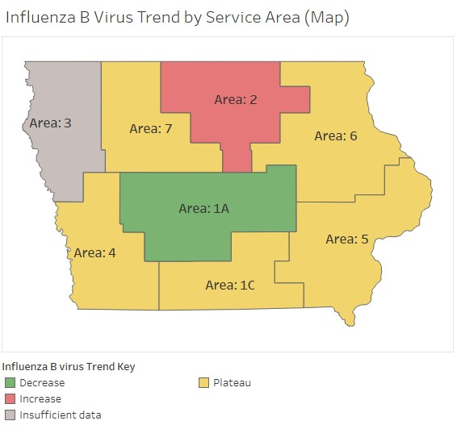
- The map shows the state of Iowa divided into eight service areas defined by Iowa Health and Human Services. The service areas are categorized as increase, decrease, plateau, and insufficient data based on the influenza B virus trend calculations. See the Definitions section at the bottom of the dashboard for more details.
- The trend key for the four categories shows different colors for the different trends.
- To the right of the map is the Influenza B Virus Trend by Service Area (Table) (Screenshot 11).

Screenshot 11

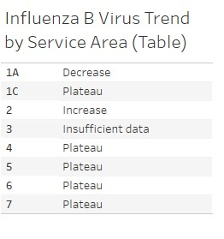
- The table provides an alternative representation of the Influenza B virus Trend by Service Area map. The table displays rows for the eight service areas as defined by Iowa Health and Human Services. The service areas are categorized as increase, decrease, plateau, and insufficient data based on the influenza B virus trend calculations.
- Further details on the methods can be found at the bottom of the screen in the Definitions section.

Navigating RSV Screen
- Starting on the lefthand side of the screen there are filter, color, and shape keys corresponding to the Average RSV Normalized to Fecal Matter line chart (Screenshot 12).
Screenshot 12
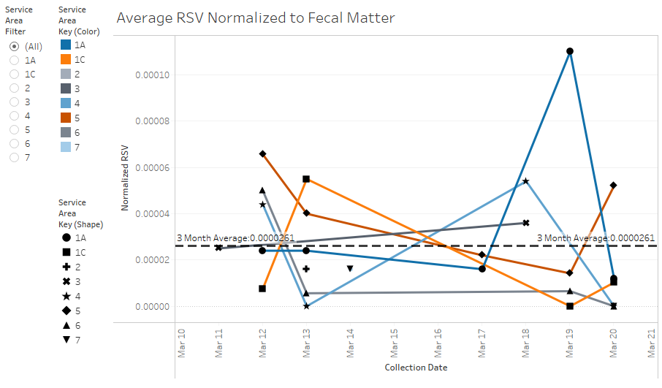
- The filter for Iowa Health and Human Services service areas shows the data for the selected option on the RSV Normalized to Fecal Matter line chart and RSV Trend by Service Area table. Options include "All" and each service area.
- The color key for Iowa Health and Human Services service areas shows the colors used to highlight specific service areas on the Average RSV Normalized to Fecal Matter line chart.
- The shape key for Iowa Health and Human Services service areas shows the shapes used to highlight specific service areas on the Average RSV Normalized to Fecal Matter line chart.
- The line chart shows average RSV normalized to fecal matter. For each of the 8 service areas as defined by Iowa Health and Human Services, the trend of the normalized RSV is shown over the last three months. Trends and data points from each of the eight service areas are distinguished based on color and shape respectively.
- To the right of the line chart is the RSV Trend by Service Area (Map) and trend key (Screenshot 13).
Screenshot 13
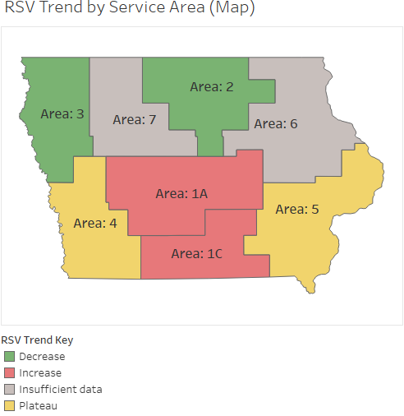
- The map shows the state of Iowa divided into eight service areas defined by Iowa Health and Human Services. The service areas are categorized as increase, decrease, plateau, and insufficient data based on the RSV trend calculations. See the Definitions section at the bottom of the dashboard for more details.
- The trend key for the four categories shows different colors for the different trends.
- To the right of the map is the RSV Trend by Service Area (Table) (Screenshot 14).
Screenshot 14
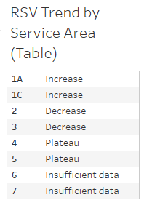
- The table provides an alternative representation of the RSV Trend by Service Area map. The table displays rows for the eight service areas as defined by Iowa Health and Human Services. The service areas are categorized as increase, decrease, plateau, and insufficient data based on the RSV trend calculations.
- Further details on the methods can be found at the bottom of the screen in the Definitions section.

Filtering and Highlighting Data
- By default, data from all service areas will be displayed. To view only a service area of interest select the radio button next to the service area in the Service Area Filter (Screenshot 15).

Screenshot 15

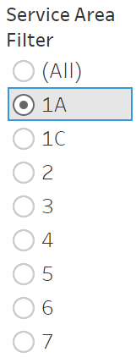

- For example, selecting a service area on the SARS-CoV-2 data screen will filter the Average SARS-CoV-2 Normalized to Fecal Matter line chart, SARS-CoV-2 Trend by Service Area (Table), and SARS-CoV-2 Predominant Lineage by Service Area to show only data from the selected service area (Screenshot 16).

  - Please note that for the Influenza A, Influenza B data, and RSV screens, no Predominant Lineage by Service Area table will be filtered as currently only SARS-CoV-2 samples are sequenced.

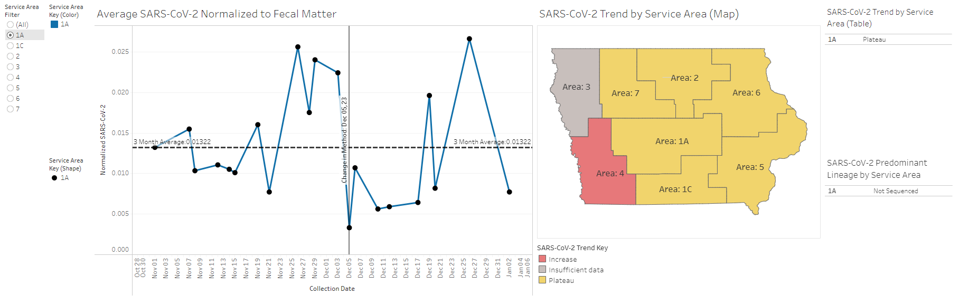
Screenshot 16

- There are multiple ways to highlight a service area of interest. Click on the appropriate row under any of the service area keys or tables. Data can also be highlighted by selecting a service area on the map or by selecting data directly on the line chart. This functionality will gray out service areas that are not selected, but the data from those service areas will be visible on screen (Screenshot 17). To undo highlighting select the same service area again or click the button in the lower right of the dashboard.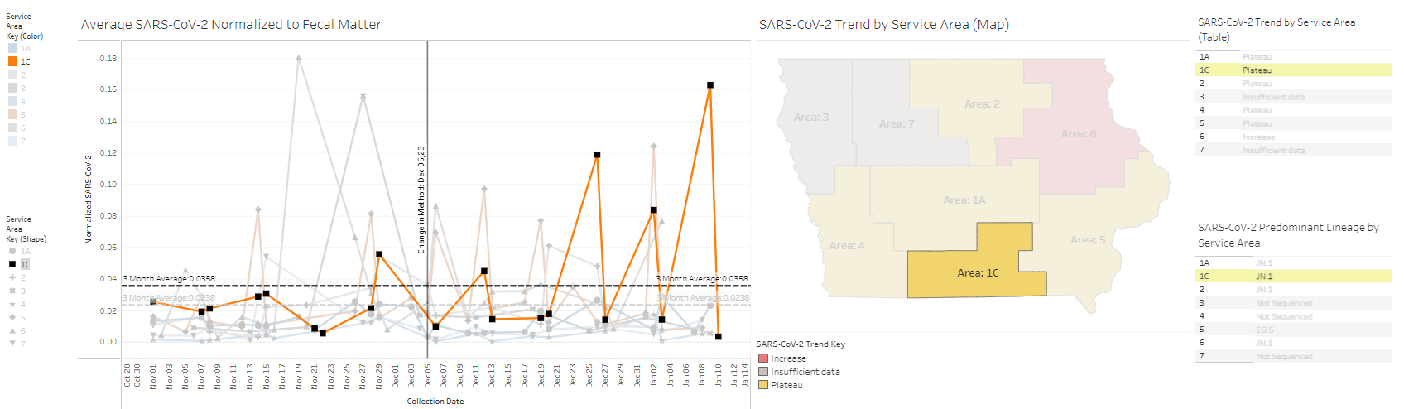
Screenshot 17

  - It is also possible to highlight multiple service areas at once. To do this hold the “Ctrl” key on your keyboard while selecting multiple service areas (Screenshot 18).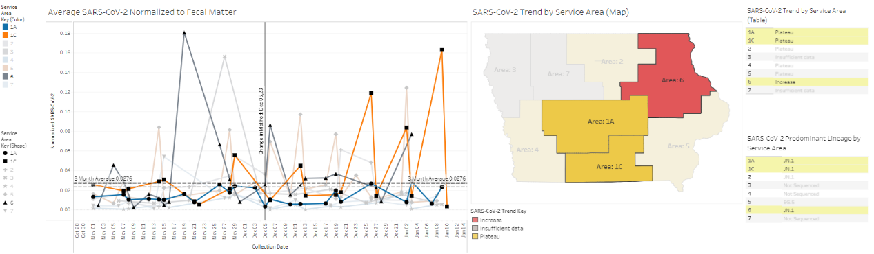
Screenshot 18

Downloading Data
- To download data, select the symbol in the lower right corner. This option may not be visible in full screen mode. To exit full screen mode, click the esc key on your keyboard or select the symbol in the lower right corner.
- There are several download file format options available (Screenshot 19).
Screenshot 19
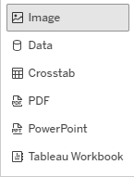
- The “Image” option will download a .png file of the current screen.
- The “Crosstab” option allows for the download of the data that is represented in the line chart or the map figure on the current screen in excel or .csv formats.
- The “PDF” option allows for customizable scaling, page size, and orientation options. (Screenshot 20). Selecting the “This Story” option on this dialog box will generate a .pdf file that includes the screenshots from each of the SARS-CoV-2, Influenza A, Influenza B, and RSV data screens. Alternatively, a specific screen may be selected.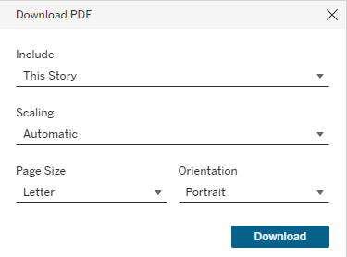
Screenshot 20
- The “PowerPoint” option can be used to download screenshots as a PowerPoint. Selecting the “This Story” option on the prompt dialog box will generate a .pdf file that includes the screenshots from each of the SARS-CoV-2, Influenza A, Influenza B, and RSV data screens. Alternatively, a specific screen may be selected.
- The “Tableau Workbook” can be used to download an interactive copy of the dashboard. Please note that Tableau software (e.g. Tableau Reader) must be installed on your local computer to open this file.

Using this Data and Limitations
- According to CDC NWSS: “Wastewater (sewage) can be tested to detect traces of infectious diseases circulating in a community, even if people don’t have symptoms. You can use these data as an early warning that levels of infections may be increasing or decreasing in your community”. View CDC/NWWS COVID-19 Wastewater Data State and Territory Trends page (https://www.cdc.gov/nwss/rv/COVID19-statetrend.html)
- CDC provides guidance on what actions can be taken in respiratory viruses are spreading in your community (https://www.cdc.gov/respiratory-viruses/index.html).
- Limitations:
View CDC/AMD Wastewater Surveillance for COVID-19 program overview (https://www.cdc.gov/amd/whats-new/wastewater-surveillance.html)
  - Unlike CDC NWSS and some other wastewater monitoring organizations, SHL does not normalize to flow rate and therefore data may not be directly comparable.
  - Potential exclusion of communities without sewer systems, such as those that rely on septic-based systems.
  - Potential exclusion of communities or facilities served by decentralized wastewater systems, such as some prisons, universities, or hospitals that treat their own wastewater.
  - Challenges in detecting low levels of the virus in a community.

